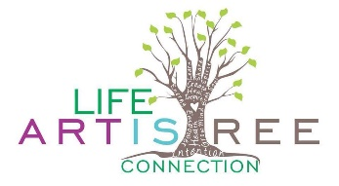
Dear Participant!
Congratulations! We have reserved your spot in the 2020 VISION MANIFESTATION RETREAT! This year will be super magical Ananya Nicole of Ananya Wellness will be leading us in gentle yoga, sacred cacao ceremony and purifying fire ceremony! Musical Shaman Massood Taj will be leading us in sacred sound meditation with his magical flutes and Tibetan singing bowls and I will offer journaling prompts that will help us get clear about what we want to let go of and manifest in our lives! All of this will inspire and accompany the creation of our own 2020 VISION BOARDS that will help us attract our ideal outcomes in the coming year!
When: Saturday, February 1, 2020
Time: 10:00 –5:00 PM
Where: Rau-wood Retreat Center, 8687 Old Harding Pike, Nashville, TN 37221
Directions: Go South on Highway 100 and pass the Loveless Café. Go 3.5 miles past green bridge. Take immediate Left on Old Harding Pike. Rau-Wood Retreat Center is on your left. Go down gravel driveway until you see two brown buildings on right. We will meet in the River Room.
What to Bring:
- A cushion, blanket and/or yoga mat (for sitting on the floor)
- Comfortable clothing. Hiking shoes or sandals for nature walk.
- Journal and Pen
- Water bottle
- Bagged Lunch (snacks will be provided).
Optional:
- Your own Magazines or pictures if you like (we will have plenty there as well)
- A picture of yourself radiant and happy.
If you have not already done so, please complete your reservation by making payment via PAYPAL to lifeartistree@gmail.com. Thank you!
If you have any questions, please feel free to contact me at 615-424-9707. We look forward to seeing you there!
With love and gratitude,
Dina Rae Capitani
http://www.thespacebetweenthenotes.org/

